# ĐẠI HỌC QUỐC GIA THÀNH PHỐ HỒ CHÍ MINH TRƯỜNG ĐẠI HỌC KHOA HỌC TỰ NHIÊN

**KHOA CÔNG NGHỆ THÔNG TIN**



# XỬ LÝ ẢNH SỐ VÀ VIDEO SỐ

# IMAGE AND VIDEO PROCESSING

# Lab04: Yolo and Darknet

**Giảng viên lý thuyết: Lý Quốc Ngọc**

**Giảng viên hướng dẫn: Nguyễn Mạnh Hùng**

**Sinh viên thực hiện:**

**Họ và tên: Nguyễn Văn Hiếu MSSV: 20127498**

**Lớp học phần: 20TGMT1**

**TP.HCM, ngày 7 tháng 12 năm 2022**

**I. Using YOLOv4 Pytorch Model**

**1. Old dataset (Chess Pieces Dataset)**

- During the running process, I encountered some errors in the Numpy library and files like train.py and models.py

- In step start training, I encountered the following error:

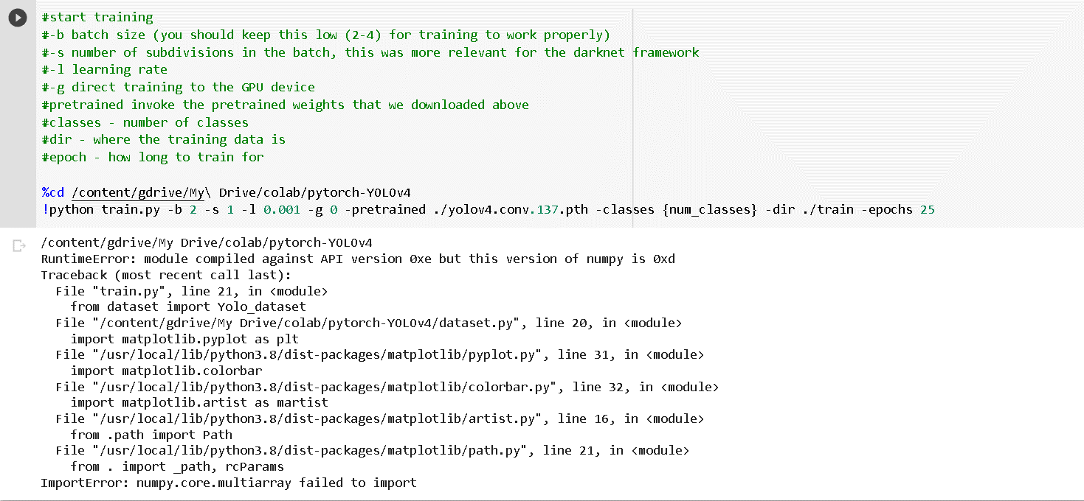

- To solve the Numpy library error, I added the following command line in the source code (remember to restart the runtime):

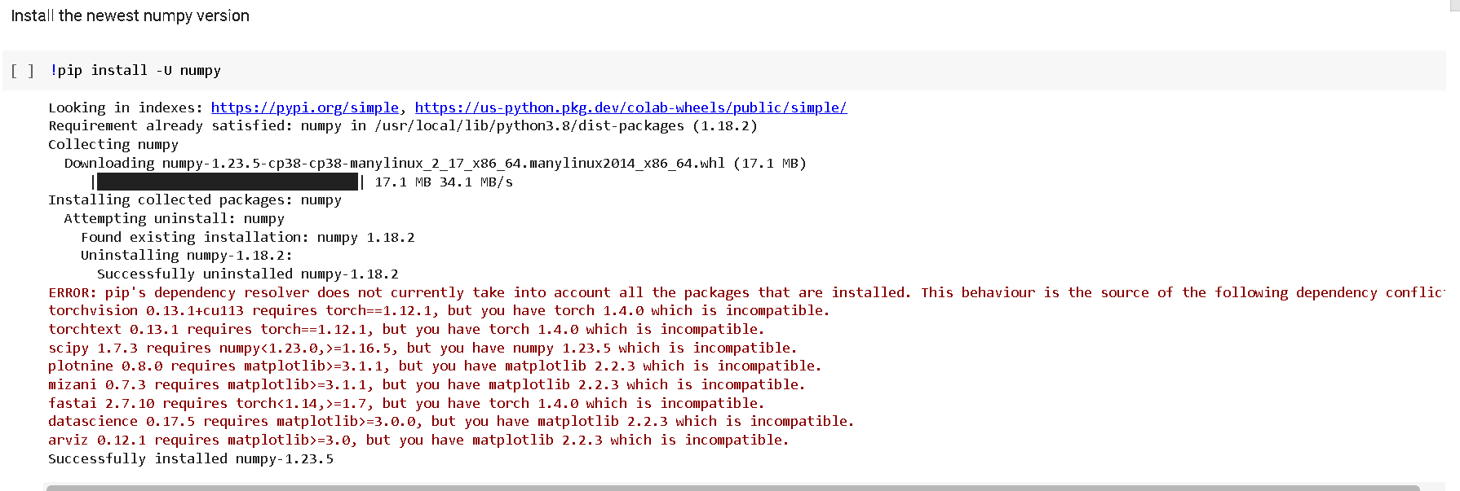

- Then, I encountered the following error:

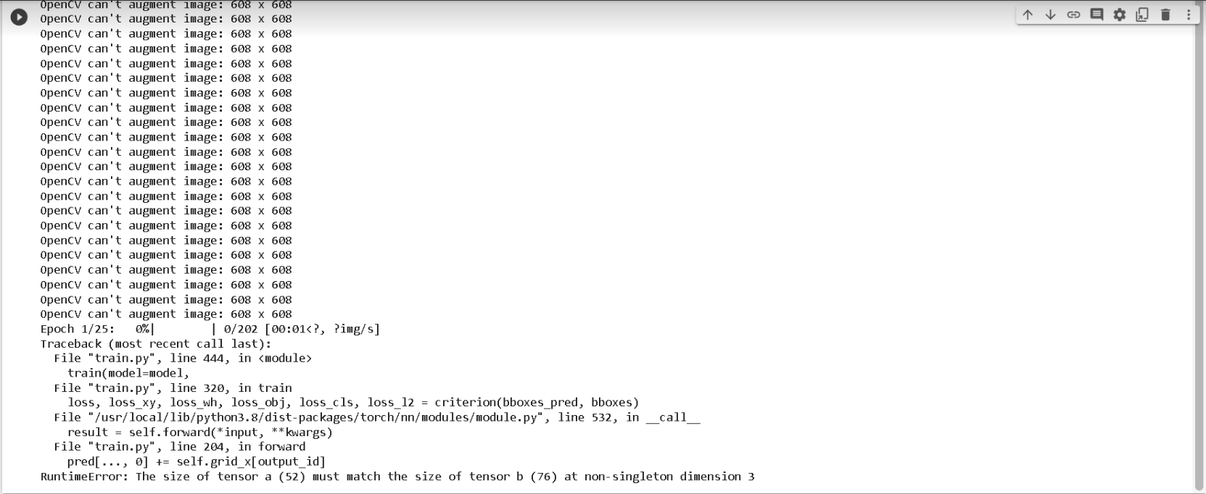

- To fix it, I adjusted the file dataset.py in location: My Drive/colab/pytorch-YOLOv4 by adding the line: hsv = list(hsv)

(The corrected dataset.py file I will leave in the source code)

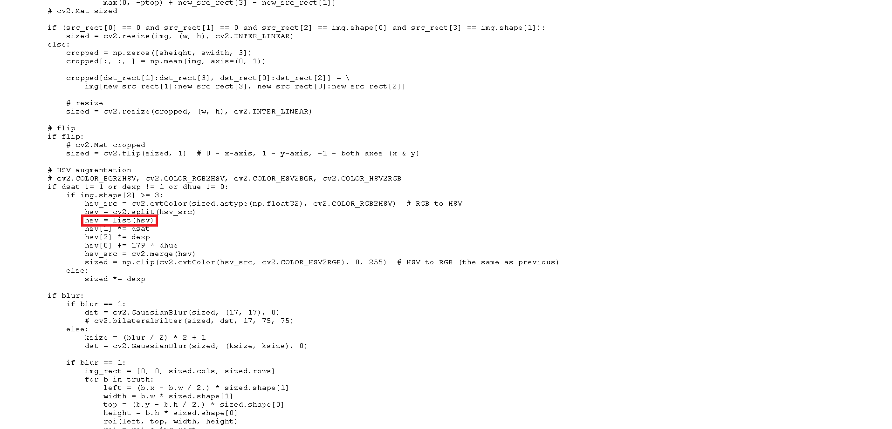

- In step run test, I encountered the following error:

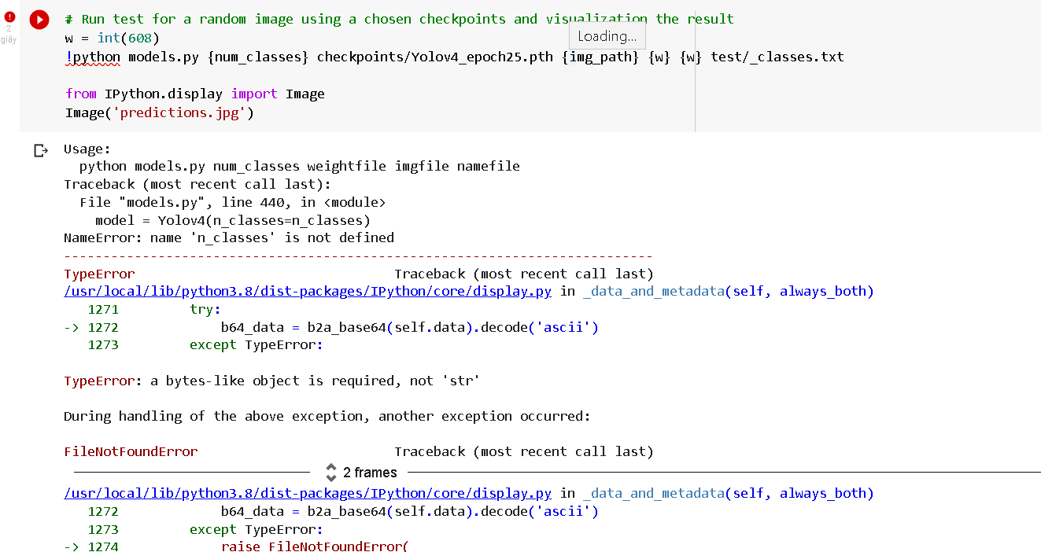- This error occurs because the command line parameters do not coincide with the models.py file, so I corrected as follows:

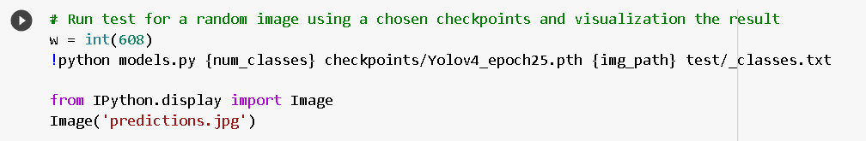

- Running step by step, according to the available source code, we will get the final result as follows:

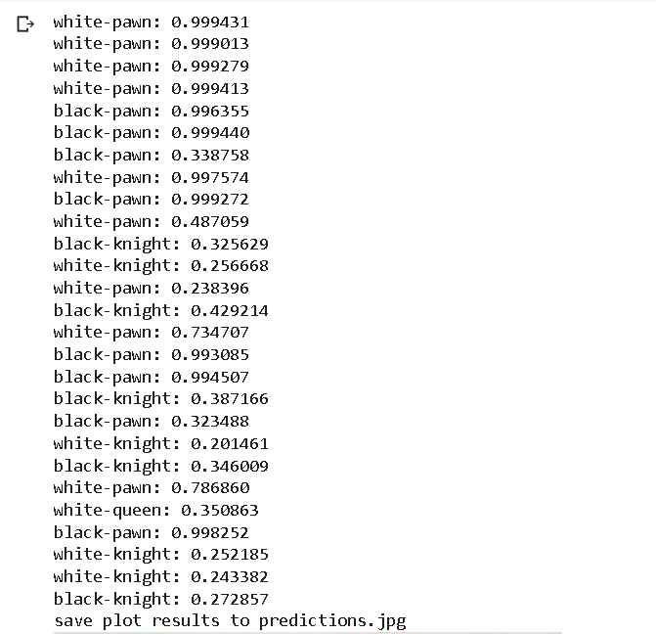

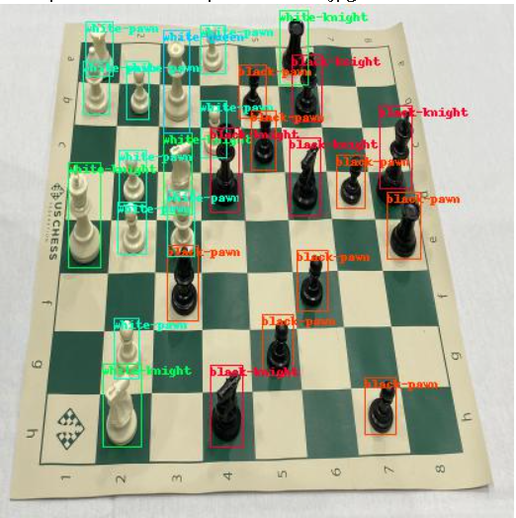

**2. Using new dataset (Vehicles Dataset)**

- Vehicles Dataset is a set of vehicles that contain 627 photos divided into3 folder train, validation and testing. In each folder also contains _annotations.txt file (labeling and class number) and _classes.txt (classes) respectively. Each image has dimensions 416 x 416.

- Dataset link: <https://public.roboflow.com/object-detection/vehicles-openimages>

- Select the format for YOLO V4 Pytorch:

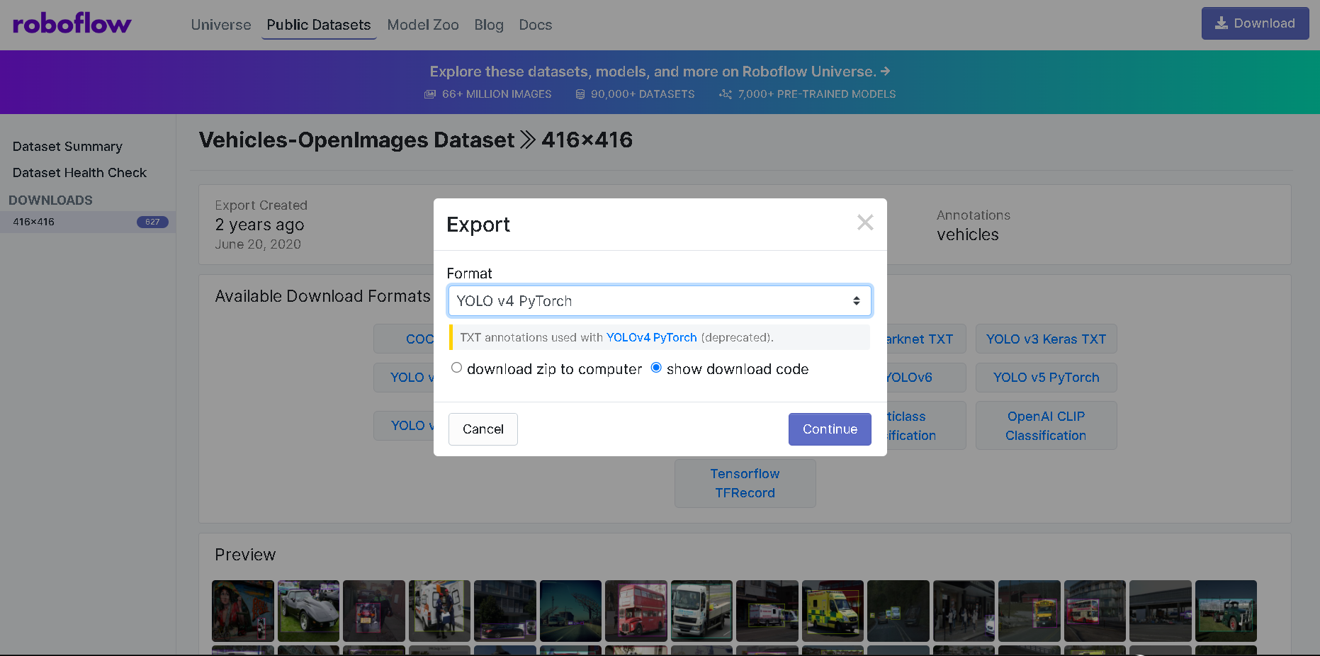

- Click “show download code” and Continue to get the download link:

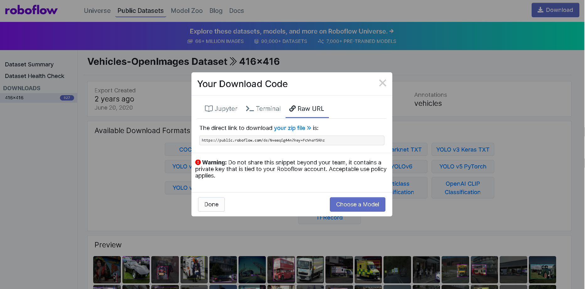

- Use Google Drive to store data as well as train results.\

- The next steps do the same with the old dataset

- Particularly, the data preparation step we will often change the zip file name of the new data instead of the old data:

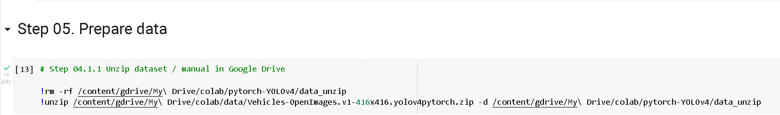

- In step run test, we will encounter similar errors with the old dataset and we will correct the same error.

- Finally, we will get the following result:

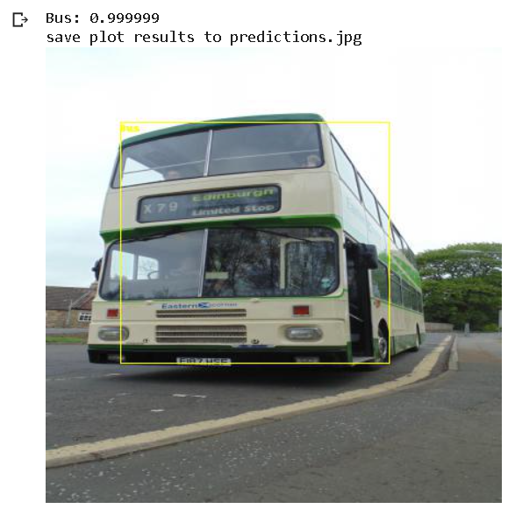

**II. Using YOLOv5 Pytorch Model**

**1. Using old dataset (Chess Pieces Dataset)**

- To take the model, you can visit: <https://roboflow.com/model/yolov5>

- Clone YOLOv5 repo:

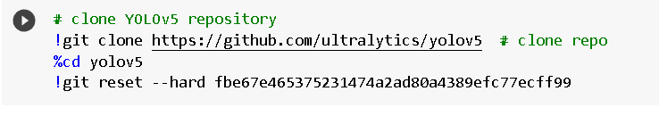

- Install dependencies as necessary:

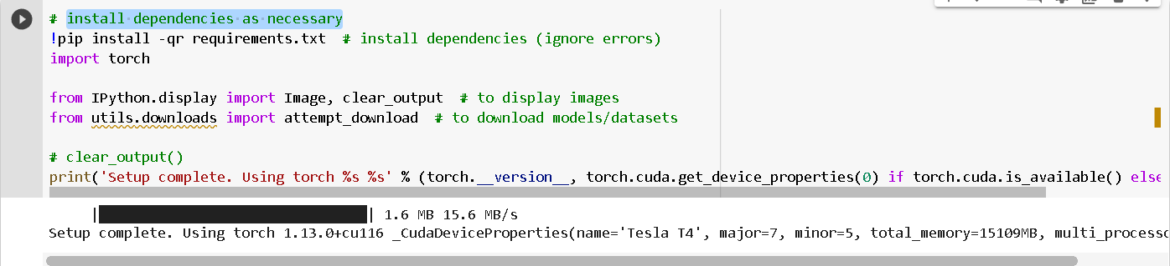

- Preparing dataset: Following the link to get the download code from roboflow: <https://app.roboflow.com/?model=yolov5&ref=roboflow-yolov5>

- Then you need to create a project for your dataset:

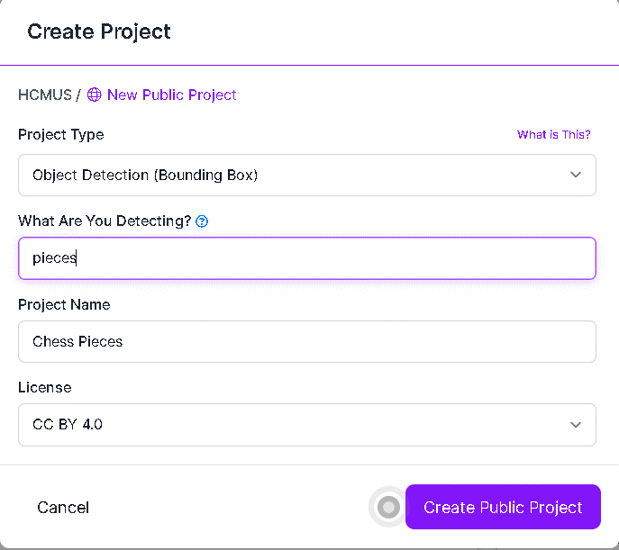

- Next, drag and drop the image and annotation from your dataset:

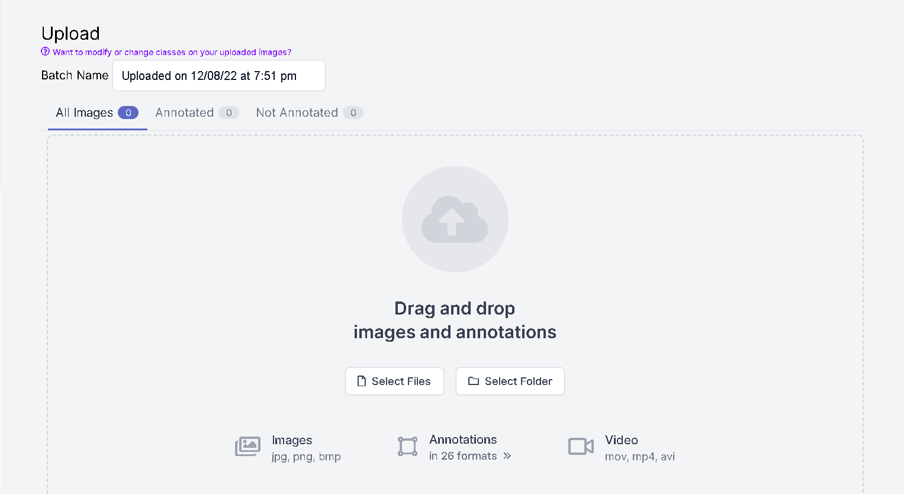

- After uploading, click Save and Continue:

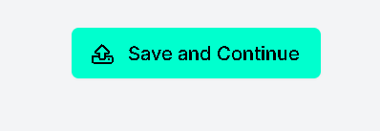

- Click Continue to split image:

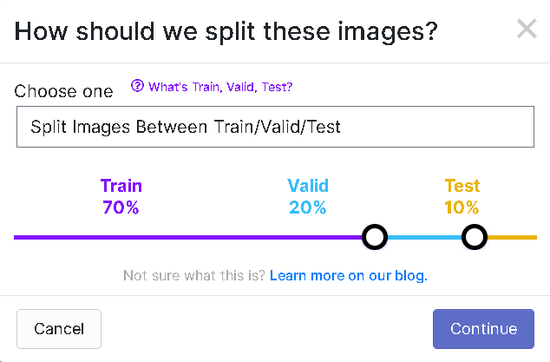

- Adjust the necessary parameters and click Generate:

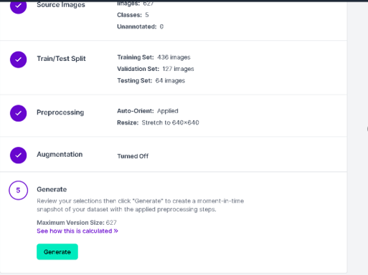

- Finally, click Export :

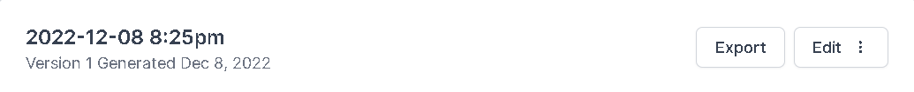

- Choose the YOLO v5 Pytorch format and click Continue:

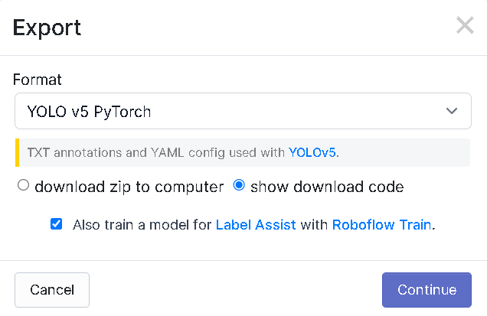

- You will create a dataset and get the download code below:

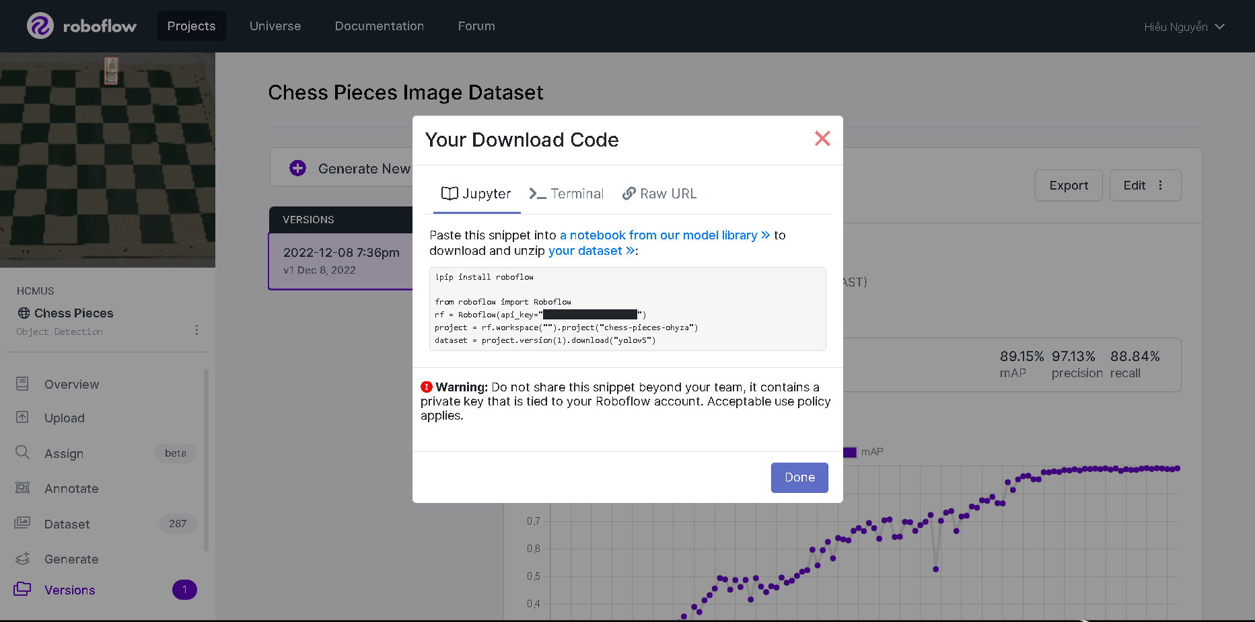

- Copy and paste it in next cell like this:

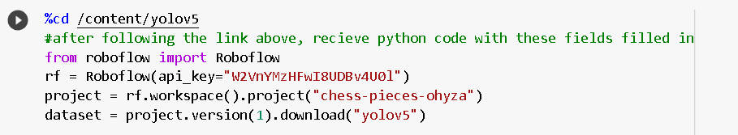

- Run it, we will get the dataset in my training:

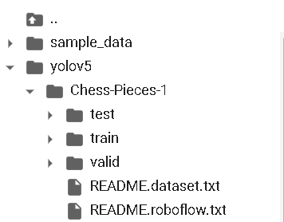

- Running step by step we will get the following result:

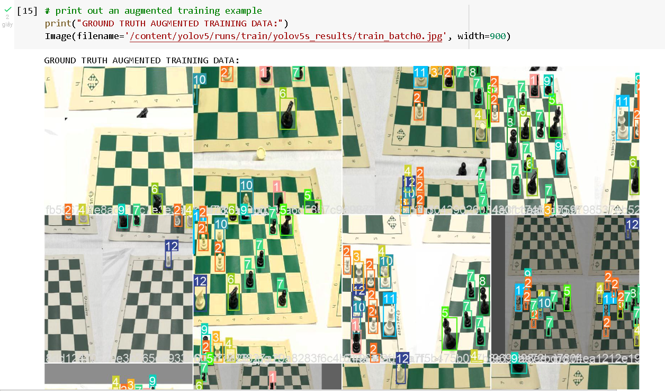

**2. Using new dataset (Vehicles Dataset)**

- Implement the same steps as the old data set, we also obtain the following results:

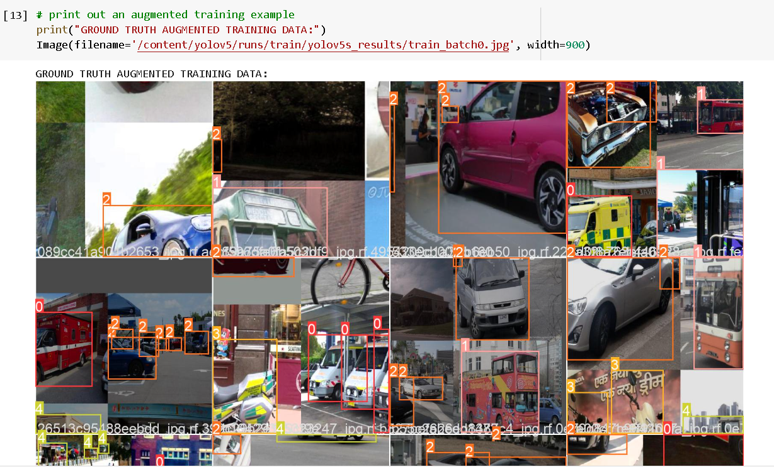

- Run Inference With Trained Weights:

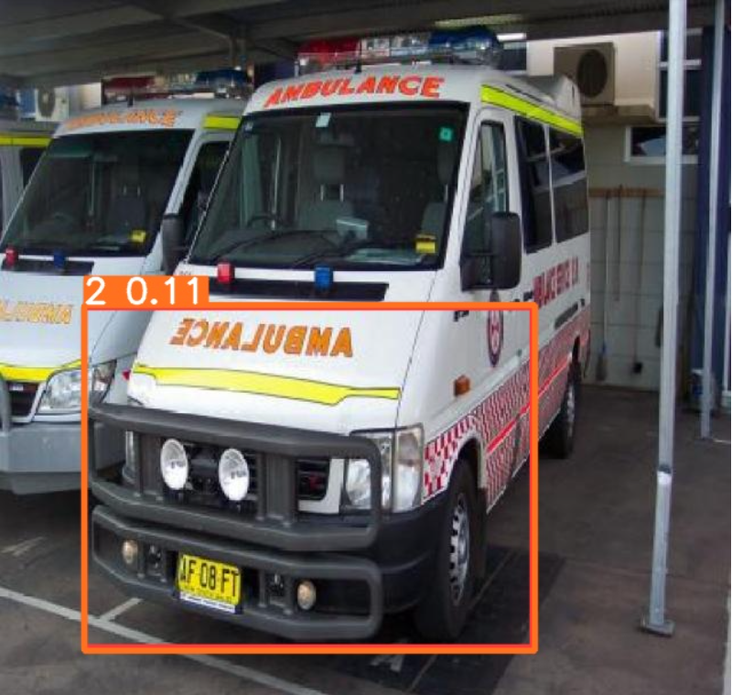

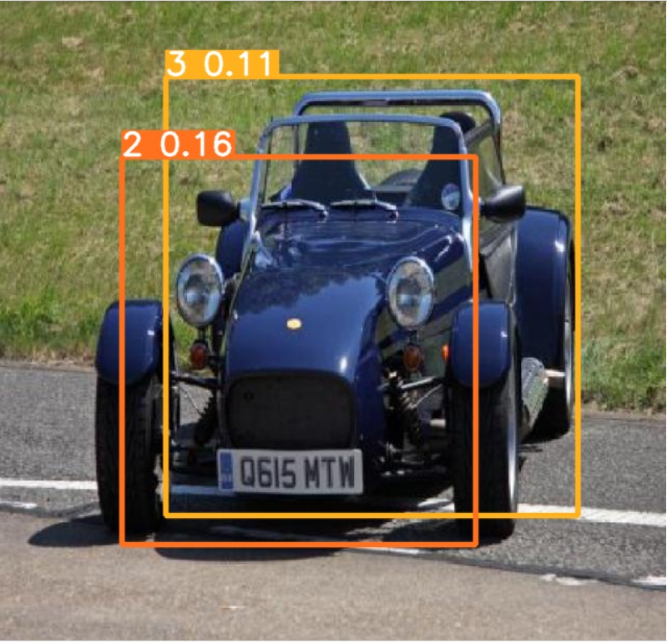

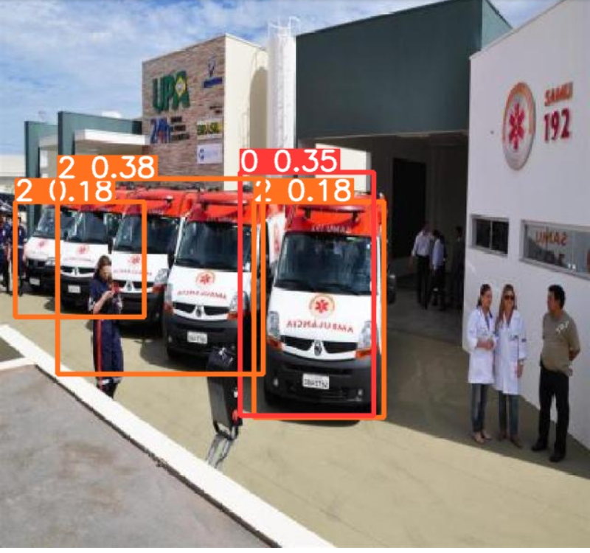

**III. Conclusion**

- Train YOLOv5-Pytorch process is faster than YOLOv4-Pytorch. However, the train speed depends on the GPU that we use.

- To distinguish the difference of these two models easily, you can follow the following link: <https://blog.roboflow.com/yolov4-versus-yolov5/>

- As a result, in both YOLOv4-Pytorch and YOLOv5-Pytorch models, it was only acceptable, and some models were not detected. This limitation may be because the data is too little or the super parameters we use is not the best because it takes a lot of time to test.